Complex Numbers Set
# Source: AI Source: Provided by: [Data Path: Persons Table -> ID Column: 1, Name_En Column: Motasem Essam] -> From: [ChatGPT] on [7/15/2026]
The Complex Numbers Set is the set of all numbers that can be written as the sum of a real part and an imaginary part. It is the most comprehensive commonly studied number set and includes all real numbers and all imaginary numbers.
Complex numbers were developed to provide solutions to equations that have no real solutions, such as
$$x^{2}+1=0.$$
They are fundamental to algebra, complex analysis, differential equations, engineering, physics, computer science, signal processing, quantum mechanics, and many other branches of mathematics and science.

Definition
# Source: AI Source: Provided by: [Data Path: Persons Table -> ID Column: 1, Name_En Column: Motasem Essam] -> From: [ChatGPT] on [7/15/2026]
A Complex Number is any number that can be written in the form
$$\boxed{a+bi}$$
where
- $a∈R$is the real part,
- $b∈R$is the imaginary part,
- $i=\sqrt{-1}$.

Symbol
# Source: AI Source: Provided by: [Data Path: Persons Table -> ID Column: 1, Name_En Column: Motasem Essam] -> From: [ChatGPT] on [7/15/2026]
The Complex Numbers Set is denoted by
$$\boxed{C}$$

Set Notation
# Source: AI Source: Provided by: [Data Path: Persons Table -> ID Column: 1, Name_En Column: Motasem Essam] -> From: [ChatGPT] on [7/15/2026]
Set-Builder Notation
$$\boxed{C=\{a+bi:a,b∈R\}}$$
This means:
"The set of all numbers whose real and imaginary parts are real numbers."

Components of a Complex Number
# Source: AI Source: Provided by: [Data Path: Persons Table -> ID Column: 1, Name_En Column: Motasem Essam] -> From: [ChatGPT] on [7/15/2026]
For
$$z=a+bi$$
- Real part:
$$\boxed{Re⁡(z)=a}$$
- Imaginary part:
$$\boxed{Im⁡(z)=b}$$

Examples
# Source: AI Source: Provided by: [Data Path: Persons Table -> ID Column: 1, Name_En Column: Motasem Essam] -> From: [ChatGPT] on [7/15/2026]
Complex numbers include
$$3+2i, \\ -5+i, \\ 7-4i, \\ 0+6i, \\ 5+0i$$

Special Cases

Purely Real Numbers
# Source: AI Source: Provided by: [Data Path: Persons Table -> ID Column: 1, Name_En Column: Motasem Essam] -> From: [ChatGPT] on [7/15/2026]
If
$$b=0,$$
then
$$a+0i=a$$
Examples:
$$5, -2, π$$
Every real number is a complex number.

Purely Imaginary Numbers
# Source: AI Source: Provided by: [Data Path: Persons Table -> ID Column: 1, Name_En Column: Motasem Essam] -> From: [ChatGPT] on [7/15/2026]
If
$$a=0,$$
then
$$0+bi=bi$$
Examples:
$$i, 3i, -7i$$

Non-Examples
# Source: AI Source: Provided by: [Data Path: Persons Table -> ID Column: 1, Name_En Column: Motasem Essam] -> From: [ChatGPT] on [7/15/2026]
There are no numbers outside the complex number system that are considered ordinary algebraic numbers.
However,
- undefined expressions such as
$$\frac{1}{0}$$
are not complex numbers.

Characteristics
# Source: AI Source: Provided by: [Data Path: Persons Table -> ID Column: 1, Name_En Column: Motasem Essam] -> From: [ChatGPT] on [7/15/2026]
Complex numbers:
- Have two components.
- Include all real numbers.
- Include all imaginary numbers.
- Form an infinite set.
- Cannot be ordered like real numbers.

Relationship to Other Number Sets
# Source: AI Source: Provided by: [Data Path: Persons Table -> ID Column: 1, Name_En Column: Motasem Essam] -> From: [ChatGPT] on [7/15/2026]
The Complex Numbers Set contains every commonly studied number set.
$$\boxed{N⊂W⊂Z⊂Q⊂R⊂C}$$
Also,
$$\boxed{\{bi:b∈R\}⊂C}$$
Thus,
- every real number is complex,
- every imaginary number is complex.

Complex Plane
# Source: AI Source: Provided by: [Data Path: Persons Table -> ID Column: 1, Name_En Column: Motasem Essam] -> From: [ChatGPT] on [7/15/2026]
Complex numbers are represented on the complex plane.
- Horizontal axis:
Real axis
- Vertical axis:
Imaginary axis
The point
$$a+bi$$
is represented by the coordinate
$$(a,b).$$

Algebraic Properties
# Source: AI Source: Provided by: [Data Path: Persons Table -> ID Column: 1, Name_En Column: Motasem Essam] -> From: [ChatGPT] on [7/15/2026]
Let
$$z_{1}=a+bi, \\ z_{2}=c+di.$$

Addition
$$(a+bi)+(c+di)=(a+c)+(b+d)i$$

Subtraction
$$(a+bi)-(c+di)=(a-c)+(b-d)i$$

Multiplication
$$(a+bi)(c+di)=(ac-bd)+(ad+bc)i$$

Division
$$\boxed{\frac{a+bi}{c+di}=\frac{\left(a+bi)(c-di\right)}{c^{2}+d^{2}}}$$
provided
$$c+di≠0.$$

Complex Conjugate
For
$$z=a+bi,$$
the complex conjugate is
$$\boxed{\overset{‾}{z}=a-bi}$$
Examples:
$$3+2i⟶3-2i$$

Modulus (Absolute Value)
The modulus of
$$z=a+bi$$
is
$$\boxed{∣z∣=\sqrt{a^{2}+b^{2}}}$$
Example:
For
$$3+4i \\ ∣z∣=5$$

Examples
# Source: AI Source: Provided by: [Data Path: Persons Table -> ID Column: 1, Name_En Column: Motasem Essam] -> From: [ChatGPT] on [7/15/2026]
Example 1
Determine whether
$$3+5i$$
is complex.
Yes.

Example 2
Determine whether
$$7$$
is complex.
Yes.
$$7=7+0i$$

Example 3
Determine whether
$$5i$$
is complex.
Yes.
$$5i=0+5i$$

Example 4
Find the real and imaginary parts of
$$-4+7i.$$
Real part:
$$-4$$
Imaginary part:
$$7$$

Example 5
Find the modulus of
$$1+\sqrt{3} i. \\ ∣z∣=\sqrt{1^{2}+(\sqrt{3})^{2}}=2$$

Applications
# Source: AI Source: Provided by: [Data Path: Persons Table -> ID Column: 1, Name_En Column: Motasem Essam] -> From: [ChatGPT] on [7/15/2026]
Complex numbers are used in:
- Algebra
- Complex Analysis
- Differential Equations
- Electrical Engineering
- Control Systems
- Quantum Mechanics
- Signal Processing
- Computer Graphics
- Fluid Dynamics
- Electromagnetics

Real-Life Applications
# Source: AI Source: Provided by: [Data Path: Persons Table -> ID Column: 1, Name_En Column: Motasem Essam] -> From: [ChatGPT] on [7/15/2026]
Complex numbers appear in:
- Alternating current (AC) circuits
- Electrical impedance
- Wave analysis
- Quantum physics
- Signal processing
- Fourier transforms
- Robotics
- Aerospace engineering
- Communications
- Computer simulations

Common Mistakes
# Source: AI Source: Provided by: [Data Path: Persons Table -> ID Column: 1, Name_En Column: Motasem Essam] -> From: [ChatGPT] on [7/15/2026]
- Confusing complex numbers with imaginary numbers.
- Forgetting that every real number is complex.
- Assuming complex numbers can be ordered like real numbers.
- Forgetting that
$$i^{2}=-1.$$
- Confusing the imaginary part with the coefficient of $i$.

Key Points
# Source: AI Source: Provided by: [Data Path: Persons Table -> ID Column: 1, Name_En Column: Motasem Essam] -> From: [ChatGPT] on [7/15/2026]
- Complex numbers have the form
$$a+bi.$$
- They include both real and imaginary numbers.
- They form the largest commonly studied number set.
- Every real number is a complex number.
- Every imaginary number is a complex number.

Complex Numbers vs. Real Numbers
# Source: AI Source: Provided by: [Data Path: Persons Table -> ID Column: 1, Name_En Column: Motasem Essam] -> From: [ChatGPT] on [7/15/2026]
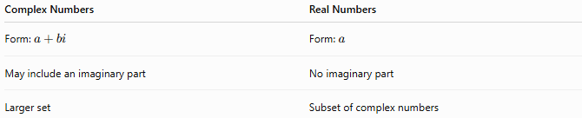
Complex Numbers | Real Numbers
Form: $a+bi$ | Form: $a$
May include an imaginary part | No imaginary part
Larger set | Subset of complex numbers

Complex Numbers vs. Imaginary Numbers
# Source: AI Source: Provided by: [Data Path: Persons Table -> ID Column: 1, Name_En Column: Motasem Essam] -> From: [ChatGPT] on [7/15/2026]
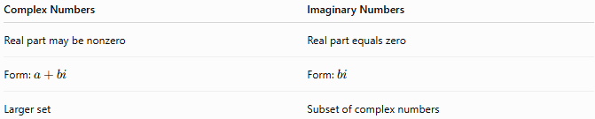
Complex Numbers | Imaginary Numbers
Real part may be nonzero | Real part equals zero
Form: $a+bi$ | Form: $bi$
Larger set | Subset of complex numbers

Complex Numbers vs. Rational Numbers
# Source: AI Source: Provided by: [Data Path: Persons Table -> ID Column: 1, Name_En Column: Motasem Essam] -> From: [ChatGPT] on [7/15/2026]
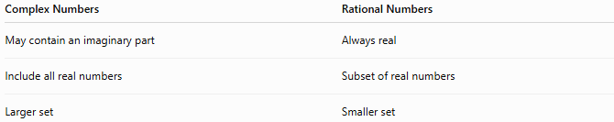
Complex Numbers | Rational Numbers
May contain an imaginary part | Always real
Include all real numbers | Subset of real numbers
Larger set | Smaller set

Relationship to Other Number Sets
# Source: AI Source: Provided by: [Data Path: Persons Table -> ID Column: 1, Name_En Column: Motasem Essam] -> From: [ChatGPT] on [7/15/2026]
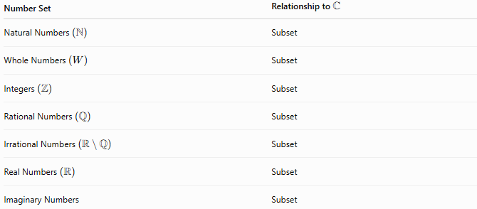
Number Set | Relationship to $C$
Natural Numbers $\left(N\right)$ | Subset
Whole Numbers $\left(W\right)$ | Subset
Integers $\left(Z\right)$ | Subset
Rational Numbers $\left(Q\right)$ | Subset
Irrational Numbers $\left(R ∖ Q\right)$ | Subset
Real Numbers $\left(R\right)$ | Subset
Imaginary Numbers | Subset

Conclusion
# Source: AI Source: Provided by: [Data Path: Persons Table -> ID Column: 1, Name_En Column: Motasem Essam] -> From: [ChatGPT] on [7/15/2026]
The Complex Numbers Set, denoted by $C$, is the set of all numbers of the form
$$a+bi,$$
where $a$and $b$are real numbers and $i=\sqrt{-1}$. It contains every real number and every imaginary number, making it the most comprehensive commonly studied number set. Complex numbers provide solutions to equations that have no real solutions and are indispensable in modern mathematics, engineering, physics, computer science, and many scientific and technological applications.

